#include <stdio.h>
#define CMPERINCH 2.54

/*function prototype*/
void inches_cm (double start, double end);
void cm_inches (double start, double end);

int main (void) {
int choice;

double start, end;

printf("Conversion table bewtween inches and centimeters :\n");
printf("(1) inches to centimeters\n");
printf("(2) centimeters to inches\n");
printf("Choose conversion type (1/2) : ");
scanf("%d",&choice);
printf ("Enter starting value : ");
scanf("%lf",&start);
printf ("Enter ending value: ");
scanf("%lf",&end);

if (choice == 1) {
inches_cm(start,end);
}
else if (choice ==2){
cm_inches(start,end);
}
else { printf ("invalid choice"); }
}

void inches_cm (double start, double end){

double cm;
printf (" Inches %8c cm \n", ' ');

while (start <= end){
cm = start * CMPERINCH;
printf ("%6.1lf%8c%6.1lf\n", start,' ',cm);
start += 4;
}
}

void cm_inches (double start, double end){

double inches;
printf (" CM %8c Inches \n", ' ');

while (start <= end){
inches = start / CMPERINCH;
printf ("%6.1lf%8c%6.1lf\n", start,' ',inches);
start += 10;
}
}
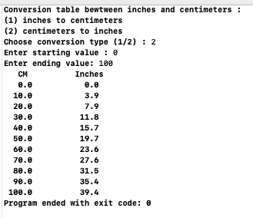

WONG KAI YUAN (DC02615-7) Assignment 4 (Wednesday 1130-1245)

